FOUNDATION FOR VIRTUAL AND AUGMENTED REALITY SYSTEMS
Lecture46
Lec-46: System Implementation
Hello and welcome to the NPTEL MOOC course on Foundations of Virtual and Augmented Reality Systems. We are discussing the system implementation stage, system implementation-related concepts, and we have already covered several key topics related to implementation. We will continue our discussion on system implementation. So, earlier we talked about the design prototype evaluate cycle.
There we have noted the design ideas, design guidelines, how to make prototypes, what kind of prototypes there are, and then how to quickly evaluate the prototypes. Now, as we have mentioned, quick evaluation of prototypes can be very helpful in getting some idea of the usability of the proposed system. We still have to go for a full-fledged robust usability testing at the end of the system implementation, and that comes under the topic of empirical evaluation. Now, we start a discussion on it. We covered a couple of stages, namely formulation of research questions and identification of variables.
So, in this lecture, we are going to continue on the empirical evaluation process. process and going to finish our discussion on it. So, if we recollect, there are four stages: identification of research questions, determination of variables, design of experiments, and analysis of empirical data, out of which we have covered this one. So, just to recollect, when we talk of research questions, essentially this is the question whose answers we seek
during an empirical study. In empirical study, generally we conduct experiments, collect data, and analyze data to find out answers to the questions that we formulate at this stage. Now, there are two types of questions if you may recollect. One is testable, the other is untestable. Testable questions are specific in nature.
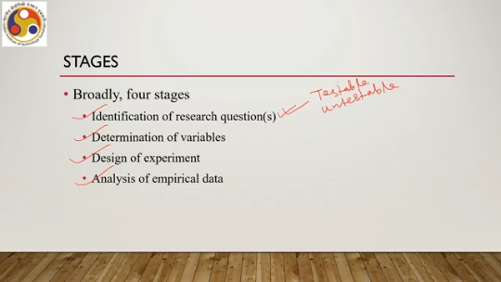
They do not generally give us; the answers to those questions do not generally give us conclusions about the overall usability of the system, or generalizability of the answer. Whereas untestable are the more generic form. The answer is relevant to a general conclusion on usability. It is possible to conduct experiments and collect data for testable questions, whereas it is not possible to conduct experiments and collect data for untestable questions. So, there is always a trade-off.
To balance the trade-off, generally what happens is that to seek answers to the usability concerns, we frame multiple testable questions, conduct experiments, collect data, and analyze data to come to conclusions about those testable questions, and on the basis of those conclusions for multiple testable questions, we come to a conclusion on the broader untestable usability-related questions. Such questions can be: untestable questions can be: is the system usable, is the system good, is the system user-friendly, and so on. Whereas testable questions can be: examples of testable questions can be: does my system
provide a lower error rate in the first two hours of usage? That is about research questions. The second thing is, in order to conduct an experiment, we need to identify variables based on the research questions. So, that is the second stage, which we have already covered. We primarily talked about two types of variables: independent variables and dependent variables.
Independent variables are also known as factors, which can take values called levels, and dependent variables are those which are dependent on the values of the independent variables. Now, we are going to talk about the third stage, that is, experiment design. This is the most important and crucial stage in the overall empirical study or empirical evaluation process. So, why is it important? Let us try to understand.
Consider the example again, the previous example that we were talking about. So, we identified a testable research question, RQ3, which is: which one is faster? We also have identified factors and levels, that is, the independent variable and its levels. So, leading to the two interfaces to study: one is our proposed interface, the other one is the existing interface.
Once that is done, then what is the next step we should do? What should we do now? So, the easiest way to get user feedback on these two interfaces is to rely on your close friends. You can simply call them up, ask them for their feedback on these two interfaces, and then based on that you can draw a conclusion.
So, it obviously involves the least hassle. You do not need to put in much effort to identify people who will be willing to provide feedback. So, you can ask five of them to participate in the experiment. To each you can show two interfaces and ask to type. So, you can give them some task and ask them to type.
Now, you can record the typing speed. Based on the typing speed, you can obviously draw a conclusion about which one is faster. So, you can get your empirical data with this method. Of course, this sounds quite logical; you are engaging end users, even though they are your friends, but they are still end users and you are collecting empirical data for further analysis and conclusion.
So, it is logical, what we want to do we are doing, and it is quite straightforward; it involves the least amount of hassle. There are many issues with this seemingly straightforward approach. In fact, this approach can lead to more problems than solutions. And why is that so? So, first of all, the users that you are engaging, are they representative of the whole user group?
You need to know. Unless they are representative of the whole user group, You cannot rely on the conclusion drawn from that group of users whom you involved in the experiment process. So, essentially what you are doing here is using a sample or a subset of all potential users of the system. Now, the subset has to be chosen carefully.
Otherwise, the subset will not be representative of the whole set. So, in that case, whatever conclusion you draw based on the results or data obtained from the subset of users will not be valid, will not be reliable. So, one important consideration when you are choosing the subset is to choose carefully based on profile information, user profile. So, your friends probably belong to the same age group and similar background. Background in the sense of educational background, socio-economic background and/or cultural background.
Now, these types of similarities generally refer to a homogeneous user group. Now, if you are building a system for such a close-knit homogeneous group, then there is no problem. However, if you are making a system to be used by a heterogeneous group of users, that is, who do not have similarity in their backgrounds, then the conclusion drawn for a heterogeneous group of users based on a homogeneous user subset will not be reliable.
Older people may have different typing behavior than teenagers. It is also likely that typing speed is different between a regular computer user and an infrequent user of computers. So, all these actually point to the fact that when choosing the users for participation in the experiment, we need to be very careful; we need to choose them carefully. And we need to choose them based on carefully selected user profiles. So whatever we are talking of is popularly called the user profile.
We need to first define the user based on well-defined user profile characteristics, user profile entries. And based on that only, we can start choosing the participants in our experiment. So that selection is important. The second thing is number: how many users we should engage in the experiment so that we can draw a reliable conclusion. Is any number good?
So, that is another important issue: number of participants in the empirical study or the experiment, the controlled experiment. In the example, we said that we have engaged 5 users. So, can I say with confidence that by engaging 5 users, whatever results we get, whatever data we collect, that is good enough to come to a general conclusion about the overall quality of the interface? Is 5 a good number?
Or we should go for a bigger number, say 10, or even bigger, say 20 or 30 or 50. Is that sufficient if we go for a bigger number, say 30? Is that sufficient? So, that is another important consideration. It is generally assumed that to draw reliable conclusions from empirical data, we should use between 12 and 25 participants. So, these are some numbers
obtained from studies, different studies; we can rely on these numbers. Of course, we can have more numbers, more than 25. However, between 12 and 25 participants, if we use in an experiment, then generally whatever data we get can be considered good enough to draw reliable conclusions. Below 12, whatever conclusion we draw may not be reliable; it may change if we increase the number.

So, one important thing is profile; the second important thing is number; the third is task. So, we need to provide tasks to the users to carry out during the experiment, and we will collect task performance data, which are supposed to be mostly objective data. and then we will analyze that data to come to a conclusion. So, in order to observe, we ask participants to perform tasks; for example, the typing task that we have mentioned in our example. Now, it is very important to decide appropriate tasks; otherwise, observed data may not be useful.
So, you are evaluating an interface there in the controlled experiment. You can ask the user to perform a limited number of tasks although the interface may support a large number of tasks. Not all tasks can be utilized or the users may not be asked to perform all the possible tasks that an interface supports due to less time or the practicality of the experiment. So, we have to carefully choose which tasks to provide to the user so that we can draw a reliable conclusion about the overall quality of the interface in terms of usability.
Like we have used a subset of users, we are also using a small subset of all possible tasks supported by the system and that subset has to be chosen very carefully. Ideally, the participants must be given a set of representative tasks. What is a representative task? When we are having an interface and we deploy it in practice, the tasks that are most frequently most commonly used by the potential user group are the representative tasks. You may notice that not all the tasks supported by the interface are used all the time by all the users.
A very small well-defined subset of tasks are used by everybody most of the time. So, that is the representative task set and we have to choose from this representative task set one or more tasks to be used during the experiment during the empirical study. Then the data collected and conclusion drawn can be reliable. For example, when we are providing a typing task, what is a representative task? Now it is not easy a random piece of text if we can if we select and ask users to type that is not considered to be a representative task.
Instead there are measures to identify strings of characters which may be considered to be representative tasks based on several measures which actually indirectly encompass activities that span all the interface, the entire interface as well as the users' typing skills. So, any random text is not an example of a representative task when we are comparing typing interfaces. Suitably chosen text strings are representative tasks which are chosen based on certain metrics and measures which we are not going to discuss any further on this.
However, just to give an example, carefully choosing representative tasks is also very important. So, there are three things: profile for choosing a proper subset of end users, then number of end users, then choosing a representative task, one or more representative tasks. And the fourth thing is assigning tasks. How do I assign the tasks to the end users?
Recall the empirical study we talked about for RQ3, research question 3. We had, we have talked about two test conditions, that is two interfaces. So, for each test condition we should have at least one task. So, for two test conditions we should design at least two tasks and ask participants to perform these tasks. Now, all five users whom we have engaged for the study performed the tasks for both interfaces in our experiment.
Now, when each participant in a study performs tasks corresponding to all test conditions, we call the study design a within-subject or repeated measures design. So, in a within-subject design, experimental design, or a repeated measures experimental design, all the participants are given all the tasks. Now, that is not the only way to assign tasks. Another way is we can distribute the tasks to different participants.
So, when we distribute the tasks to participants, we call the study between-subjects. So, in the case of a between-subjects experimental design, not all participants get to perform all the tasks corresponding to all the test conditions. A subset of the participants are given specific tasks; other subsets are given different tasks. So, the tasks pertaining to all the test conditions are divided and distributed among the participants; that is called a between-subjects design.
So, we have two ways to design the experiment: one is within-subject or repeated measures, and the other one is between-subjects. Clearly, within-subject designs are easier to manage; we do not need to bother much We simply give all the tasks to all the participants. However, it may lead to something interesting known as the practice effect. What does this mean?
Suppose one user is given five tasks to perform. Now, generally what happens is that the more we practice, the more expert we become. That is human nature. So after performing the first task, the user acquires certain skills. So when the second task comes, the user performs better.
When the third task comes, the user's performance may further improve. And by the time the last task comes, the user performs at his best. Now, whether this improvement in performance is due to the design or due to the practice effect, due to our inherent nature of acquiring skills while practicing, is difficult to say. So, there is a confusion about the quality of the interface: whether the interface helps the user to acquire the skills or it is because of human nature that the skills are being acquired.
So, that is generally called the practice effect. It confounds the analysis. It is also known as a confounding variable, but more about it can be found in the reference at the end. Now, when we are talking about within-subject design, this practice effect may pollute, may induce noise in the data, and it will be difficult to conclude based on the task performance whether this is due to the practice effect or due to the quality of the interface.
So, that is one problem. Now, in order to avoid that issue, in order to get noise-free or unpolluted data. Different statistical measures can be taken. One such measure is randomizing the task sequence. Another such measure is systematically changing the task sequence, such as a Latin square design, where we systematically vary the sequence of tasks to be assigned to each participant.
So, for example, suppose we have numbered the tasks as 1 to 5 and numbered the participants as 1 to 5. So, participant 1 may get tasks in the sequence 1 to 5 as shown in this table. So, task 1, task 2, task 3, task 4, task 5 in this sequence; suppose participant 1 gets Participant 2 will not get this sequence. Instead, it will be shifted by 1.
So, T2, T3, T4, T5, then T1. Participant 3 will get it in this order: T3, T4, T5, T1, T2, and so on. So, if we systematically vary the allocated task sequence for each participant, then that is called a Latin square design. Alternatively, we can also have a randomly varying task sequence for each participant.

Now, statistically, these random or systematic variations are supposed to nullify the effect of practice effect. Now, it is generally not easy to design or decide The right experiment design, whether we should go for within subject or between subject, depends on circumstances. It depends on the availability of participants. It depends on the availability of resources.
Sometimes we may have to be forced. We may be forced to go for between subject. Sometimes it is more practical to go for within subject and so on. Within subject is always easier to manage as compared to between subject, but circumstances may force us to go for between subject in many cases. So, that is stage 3, experiment design.
Just to recollect, in experiment design we have three stages, four stages that is first identification of participants based on profile, then identifying the number of participants, Then the tasks, representative tasks we have to identify and finally task assignment, how to assign the tasks whether within subject or between subject. Now, let us move to the last stage that is stage 4 which is data analysis. So, we have conducted the experiment and collected the empirical data. What next? What to do with the data and how do I analyze that data.

So, through the experiment we collected data, then what to do with this data? That is the main purpose of stage 4, data analysis. We can use the data for drawing some conclusions on the efficacy of our design in terms of text entry speed. A straightforward conclusion can be misleading. Why is that so? We are dealing with samples rather than the actual population of users.
Now, where is the guarantee that the observations were not due to chance? So, today we got some data and came to a conclusion; tomorrow if we change the set of users or change the set of other conditions, Will we be able to get the same data with the same conclusion? Where is the guarantee for that? How do we know that whatever we got today, whatever results we got today, are not due to chance?
So, we need some way to know how much we got by chance and how much is actually due to the inherent nature of the interface and interaction that we have designed, not by chance. So, if we conduct another study with a completely different set of participants and interfaces, we may end up with a completely different dataset leading to a different conclusion altogether; that is possible if we are getting the result by chance. Now, if we are not getting it by chance, then that is not possible. So, we need to be sure whether whatever data we are getting is not by chance before we can draw a conclusion.
In summary, what we are trying to say here is that once we collect data, immediately if we try to draw a conclusion, that is not a very good idea. It may be due to chance that we got that data. So, our conclusion will be again based on chance. Instead, we first process the data to know its reliability before we start drawing conclusions based on the data. So, the fundamental concern here is that we work with samples, but want to draw conclusions about the larger population,
whether the result is applicable for any user and any text input interface in our example. Although we are collecting data only from a limited set of 5 users, we want to draw conclusions for any user for any text entry interface. So, our starting point is a statistic that is the data, the processed data. We start with mean or average of a group of data items that is the sample. Typically, we are interested in testing statistical significance of the difference between the means of several groups of data in most situations.
So, this statistical significance can tell us whether the data is reliable or not. If it is statistically significant, if the difference is statistically significant, that means we are not getting the data by chance. If it is not statistically significant, then we are getting it by chance. So, before we start drawing conclusions, we need to test for statistical significance of the data that we got. That is what we need to do in the
data processing or data analysis stage. For example, let us consider again this RQ3. We now, this time, suppose we have 12 participants and 2 interfaces, we get 2 groups of text entry speed data. This is a within-subject design, as you can see all 12 are given all the tasks and we collected 2 groups of text entry speed data. This is sample data showing participants P1 to P12, and then for our design, these are the text entry speeds obtained.
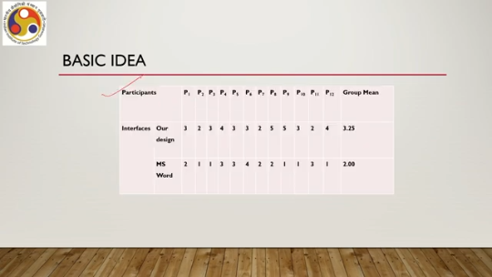
For the existing interface, these are the text entry speeds obtained by the participants. We took the mean for our design as well as the text entry speed for the existing system. Now, from here, if we directly say that because the mean text entry speed in our design is higher than that of the existing design, our design is better, then we may not be correct. We may have gotten this result by chance. So, in that case, our conclusion will be unreliable.
Instead, first we need to check for the statistical significance of the difference between between these two means. If it turns out that the difference between these two means is statistically significant, that means we have not gotten it by chance. So, irrespective of the conditions or the set of users, tomorrow if we conduct the experiment afresh, we will still get some difference between the two means. It may not be exactly the same value, but the difference will be in the same way and
we can conclude that our design is better than the other design in terms of text entry speed or efficiency. So, we are not concerned about the absolute values which may change if we change the participants or the experimental conditions. Rather, we are more interested in the relative difference. So, we see that The relative difference between the two is there.
One is higher than the other. So that relative difference is what we are more concerned about. To confirm the reliability of observations, that is, this relative difference will persist irrespective of changes in experiment, we need to go for statistical significance tests. The test tells us whether this relative difference is
by chance or due to the test conditions, and accordingly we can draw a conclusion. Now, there are different ways and different methods to perform a statistical significance test depending on the nature of the input data. So, if you perform the test, there are tools available for doing that. You are likely to get something like the following table: the difference in group means is 1.25, which is the absolute difference; the two-tailed p-value some value is mentioned; T value is some value is mentioned; degrees of freedom something is mentioned; the difference is statistically significant.

So, these are essentially things indicating that we have conducted a statistical significance test. In this case, a paired sample T test, the P value essentially refers to the probability of obtaining the data by chance. The lower it is, the better, meaning we have not obtained it by chance, and other values are related to the test. So, the details we can avoid; we can skip. For more information, you can refer to the study material mentioned at the end; further study material is mentioned at the end. Typically, such results are reported as follows: t = 1.70, p < 0.05, statistically significant.
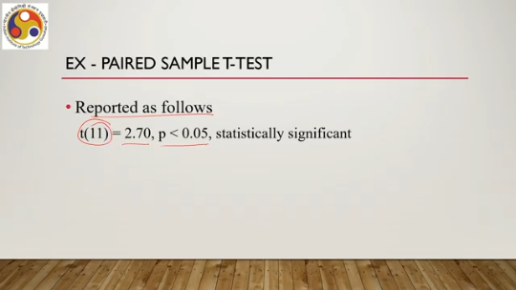
This is the standard way of representing any statistical significance test. In this case, it is known as a paired sample t-test. Only one type of test that we have covered in this example. So, there are actually a large number of statistical significance tests. One group of tests is known as parametric tests; the other group is known as non-parametric.
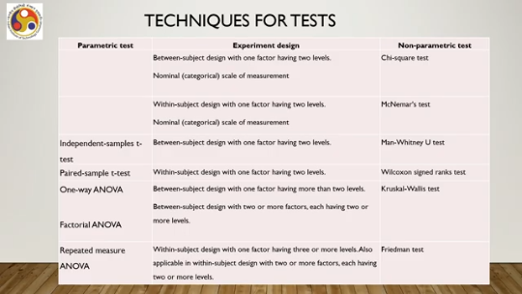
Now, if we have an experimental design as a between-subject design with one factor having two levels, then we need to go for a non-parametric test known as chi-square test. Then, if we have a nominal or categorical scale of measurement in our experimental design, then also we need to go for chi-square test. Now, if we have a within-subject design with one factor having two levels and nominal or categorical scale of measurement, then another non-parametric test is recommended, that is McNemar's test. So, if we have between-subject and nominal scale, then chi-square test. If we have within-subject and nominal scale, then McNemar's test.
In both cases, we have one factor with two levels. If we have a between-subject experimental design with one factor having two levels and nothing else is mentioned, then we can go for either independent samples t-test, which is a parametric test, or Mann-Whitney U test, which is a non-parametric test. For a within-subject design with one factor having two levels, we can go for a paired sample t-test, which is a parametric test, or Wilcoxon signed-rank test, which is non-parametric. Similarly, for a between-subject design with one factor having more than two levels, we can go for one-way ANOVA.
If we have a between-subject design with two or more factors each having two or more levels, we can use factorial ANOVA. Both of these are parametric. parametric tests. Also, we can go for the Kruskal-Wallis test if we have a between-subject design with one factor having more than two levels. If we have a within-subject design with one factor having three or more levels, also
applicable in within-subject design with two or more factors each having two or more levels, we can go for repeated measures ANOVA, which is a parametric test, or the Friedman test, which is a non-parametric test. So, we have options to go for different types of statistical significance tests depending on the design of the experiment and the nature of the data, and using either of these tests, we can actually get to know whether the results that we are obtaining are by chance or they are due to the test conditions, that is, whether our design is good or bad.
So, with that, we have come to the conclusion of this part of the lecture. So, in summary, we can quickly recap that we have talked about the design prototype evaluate cycle, then how to build and evaluate prototypes; we also talked about the full-fledged empirical evaluation with a larger number of users and a fully developed system. In the next part of this lecture, we will be talking about the Majuli tour evaluation,
how we evaluated the tour that we have developed and demonstrated in the previous lectures, and what knowledge from these lectures that we have covered was utilized while evaluating the tour. So, I hope you could follow the lectures. You could understand the concepts. Looking forward to meeting you in the next part of the lecture. Till then, thank you.
Goodbye. Happy learning.

